HOW TO USE THE SUNDIAL
The clock that
can’t go wrong
– it turns with the Earth

Time
Use the centre of the shadow of the gnomon.
Read Sun-time from the numbers on the scale
(in winter at the top, in summer at the bottom).
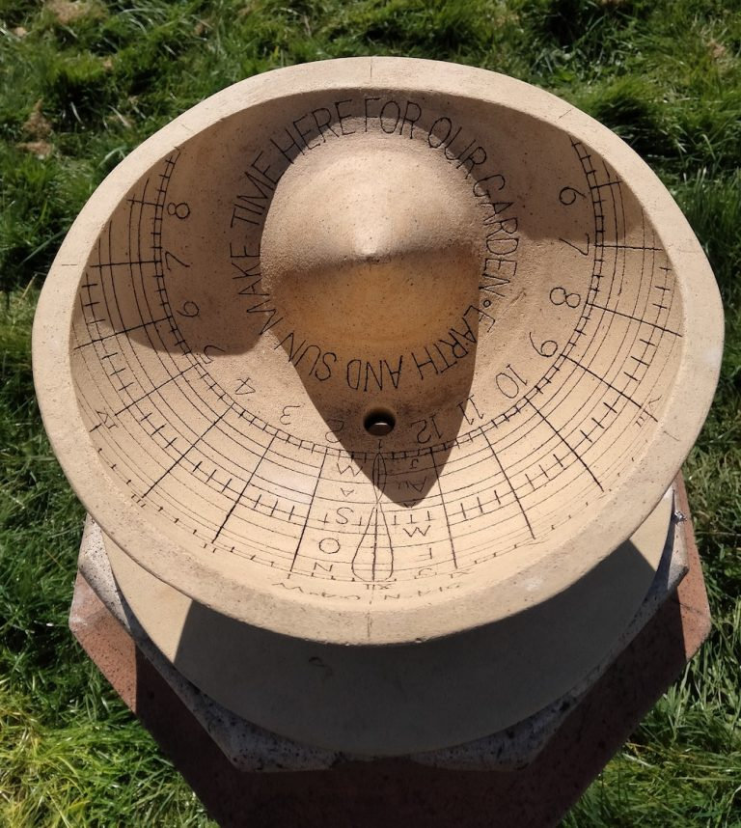
Date
See time of year from month lines
indicated by initial letters J, F, M etc. December and July, shown by the top and bottom edge markings.

Clock-time
The 8 shaped curve, or analemma, is the Equation of Time, indicating the position of the Sun at midday throughout the year.
Its difference from the midday line
converts sun-time to clock-time.

And you can see:
Day length through the year,
Sunrise and sunset times,
Sunrise and sunset directions,
Longitude relative to Greenwich,
Latitude (from how we cut the pot),
Polar direction // Earth axis,
Solstice and Equinox.

And imagine:
Tilt of Earth axis and elliptical
track of Earth orbit round the Sun,
as embodied in the sundial markings.

All this:
Makes our seasons
Made life evolve
Made earth from Earth
To enable us
To make our garden.

